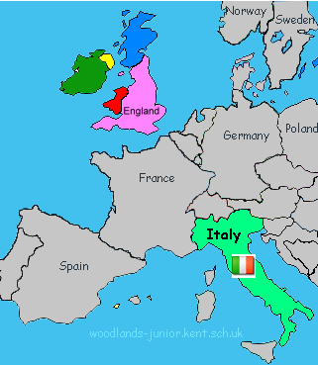
Home Learning – Year 3 T5 and 6: What did the Romans do for Bristol?
This is the home learning activity sheet for Term 5 and 6. We would like your child to complete all of the essential activities and complete 4 tasks from the topic-based list during the whole term or surprise us with something else related to our topic and learning in class! We will celebrate the children’s achievements and activities in class throughout the term.

RE: Research the Roman Gods and either make a poster of your favourite Roman god or create a ‘top trumps’ card?
History: What did the Romans give us? What do we have today that originated from the Romans?
ESSENTIAL
- Reading 5 times a week and recorded in reading record.
- Spelling practice at least five times per week for 5-10 minutes.
- Times table practice each week at home.

(The following website will help http://www.primaryhomeworkhelp.co.uk/Romans.html#7
Visit the Roman Baths in Bath. Find out as many countries as possible that the Roman’s invaded.
Art: You could make a mosaic floor pattern. Research different designs and then design your own.
This website will help: http://downloads.bbc.co.uk/history/handsonhistory/romans_mosaic.pdf
Create a 3D model of something Roman. Draw a picture of something Roman e.g. a chariot race!
Science: Try making some Roman medicine, (with an adult!) This website can help:
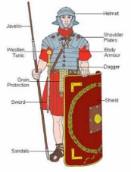
http://www.historylearningsite.co.uk/ancient-rome/medicine-in-ancient-rome/
Maths: Learn about Roman Numerals. Create some word problems with Roman Numerals.
Draw a clock face and add the Roman Numerals.
English: Write a poem or produce a poster about your favourite Roman god.
Write a diary entry of the day in the life of a Roman soldier or servant.
DT: Design a front page for the next ‘Horrible Histories ‘book all about the ‘Rotten Romans.’ Research Roman
foods and bring your creations in for taste testing!
Geography: On a map of Italy, label the main cities. Find out facts about the city of Rome, e.g. ‘When was the
Colosseum built in Rome? What is the weather like in Rome compared to Bristol? (Keep a diary of the weather
for Rome and for Bristol for a week, what do you notice?).

