Handwriting at Stoke Bishop CoE Primary School

Intent
At Stoke Bishop Primary School we value the importance of handwriting, from the early mark making stages of Reception to developing their own style by Year 6. Handwriting is a skill which allows for effective communication across the curriculum and successful handwriting allows for a greater ease and fluency in writing. Children can also gain a great deal of pleasure and self-esteem from a piece of work that looks good.

Implementation

There are five main stages to handwriting in our primary school
1. Readiness for writing, developing gross and fine motor skills, and learning correct letter formation for each new sound acquired (Explorers Hub)
2. Introduction to the cursive style of writing and grouping letters (Discoverers Hub)
3. Beginning and securing joins (Discoverers Hub)
4. Practising speed and fluency (Inventors Hub)
5. Presentation skills (Innovators hub)

Whilst there is an age group associated with each stage this is only a guide and to ensure progression, each child will develop through these stages at their own pace and with support as required.

We use teachhandwriting.co.uk website to support this progression. This has a parent's section which offers useful support and video clips to aid the link between home and school.
Readiness for writing
In Reception the children are supported in their gross and fine motor skill development through activities such as but not exclusively "Big Play", "dough disco", "funky fingers". They are also taught the correct posture, sitting position and pencil grip for effective handwriting. A progression in mark making can be found here. (link to other doc)
As the children learn each new sound in phonics they are taught how to form the letter and use a mnemonic to help them to remember.
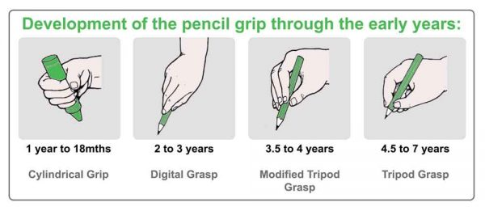
Introduction to cursive style
The children are reintroduced to each single letter as part of a family of letters. They are taught how to start on the line and up as per the cursive style of writing. Each letter is taught individually, in words and as part of the group in which is belongs. We use the sky, grass and mud approach to explicitly teach children about letter size. At this stage the children continue to secure correct pencil grip and posture for writing through fine and gross motor skill activities.
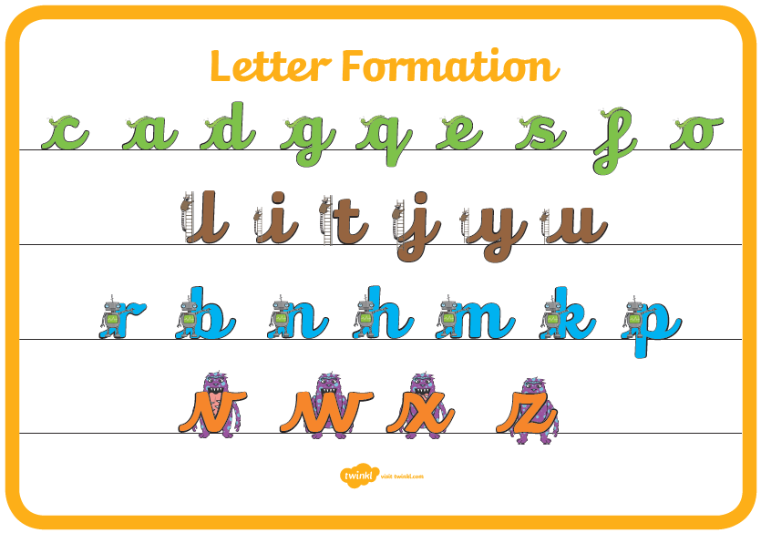
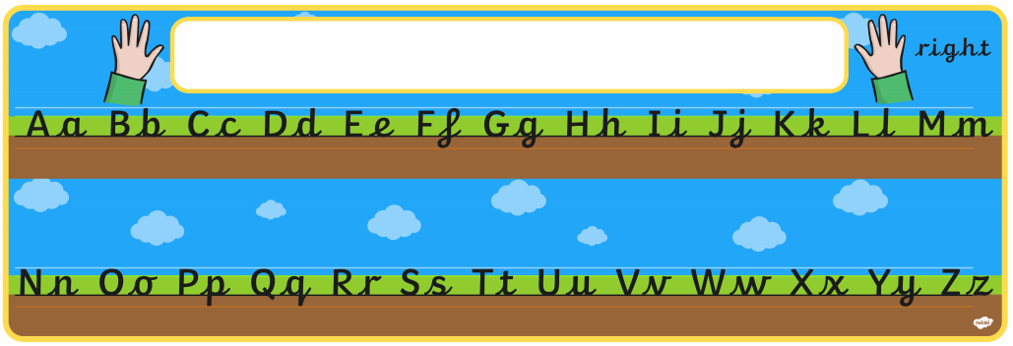

Beginning and securing joins
Once the children are familiar with the single letter cursive handwriting style they move fairly swiftly onto teaching joins. We find that in learning joins children see the reason for cursive and it helps their writing develop "a flow". Again, the teachhandwriting website is used to support, starting with lower joins. The children practise this explicitly on a weekly basis and it is modelled daily.
Practising Speed and Fluency
Children continue to use the diagonal and horizontal strokes needed to join letters and understand which letters, when adjacent to one another, are best left un-joined. Handwriting continues to be taught, with the aim of increasing the fluency with which children are able to write down what they want to say. This, in turn, will support their composition and spelling. It is at this point that some children may begin to write in pen.
Presentation Skills
Children are now encouraged to use their own style of fluent and legible handwriting. They use pen to write in their books. Children for who handwriting is not legible or fluent are given additional support through teacher/pupil discussion or individualised and specific target setting. This may be linked to the size of writing or awareness of line placement. Parents are encouraged to support and are a part of these conversations.
During the latter two stages the children are given the opportunity to earn their “Pen Licence”. This is when both the child and their teacher decide that their handwriting is sufficiently competent and legible to move from pencil to pen. This begins in Year 3 when children are given a specific target to work on regarding their handwriting. This is shared with parents so that they can practise at home and at school. In Year 5, when the teacher deems appropriate all children are given a pen to write with (no licence required!)
Children in Years 2-4 use handwriting books (with additional lines) to support their letter size and consolidate use of ascenders and descenders during handwriting lessons.
Impact
Children have high expectations, pride in their work and in its presentation. They have their own fluent, cursive handwriting style which allows their imaginations to flourish and their writing to reach its potential.

