North Bristol School Games

Keeping kids and families active during COVID-19 virus isolation

Physical and Mental well-being is so important to us all. Here are some fun & simple ideas to get children and adults ‘up and active’ in keeping fit and healthy during their time not in school.

We hope you enjoy having a go at some of these activities.

Physical activity Score card – Keeping kids and families active during isolation
Activity | Picture of how do the activity | Score | Score | Score | Score | Score | Score
Press up  How many press ups can you do in a row without stopping  (choose your level) | 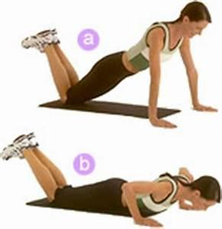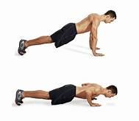  Easy Hard
Burpees  How many burpees can you do in a row? | 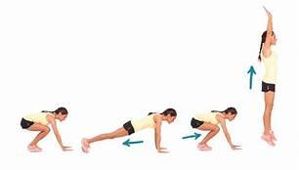
Sit ups  How many sit ups can you do in a minute | 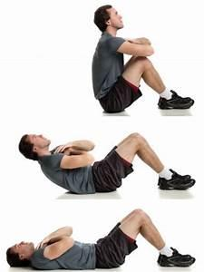
Skipping with a rope  how many skips can you do in a minute | 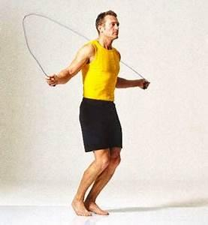
Wall sits easy  how long can you sit against the wall, without moving | 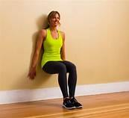  Easy Hard
Plank  Can you hold the plank  30 seconds easy  40 seconds medium  60 seconds hard | 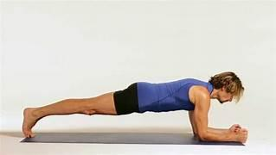
Squats  Choose a level  EASY – 30 seconds  MEDIUM – 45 seconds  HARD – 60 seconds | 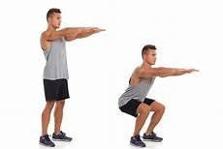
Scissor kicks  Choose one of the levels for the scissor kicks;  EASY – 20 seconds  MEDIUM – 40 seconds  HARD – 1 minute | 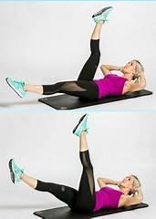
Lunges  Choose a level  EASY – 30 seconds  MEDIUM – 45 seconds  HARD – 60 seconds | 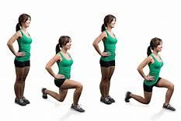
Spiderman plank  EASY – 30 seconds  MEDIUM – 45 seconds  HARD – 60 seconds | 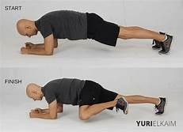
Other Physical Activities to try at home
https://www.sportengland.org/news/how-stay-active-while-youre-home
Sport England have produced tons of resources to help keep you active, over this time of isolation
- GoNoodle
www.gonoodle.com fun dance moves and active games online. Free to subscribe – tons of fun activities which the children will be familiar with as many schools use this site for brain breaks and wet play.
- BBC SuperMovers:
Fun dance/movement videos with some of your favourite CBeebies/CBBC and other well known characters
https://www.bbc.co.uk/teach/supermovers
https://www.bbc.co.uk/teach/supermovers/times-table-collection/z4vv6v4
- Joe Wicks ‘The Body Coach’ workouts on you tube

He has some brilliant sessions aimed at kids and safe for all the family.
Eg:
https://www.youtube.com/watch?v=0xE3CppbVeA
https://www.youtube.com/watch?v=TUp2_VAHIrI
https://www.youtube.com/watch?v=xLHA5g-82vY

- NHS 10 minute workouts
https://www.nhs.uk/live-well/exercise/10-minute-workouts/
- Set an Indoor scavenger hunt
Find the following items in your house. Use a phone or tablet to take pictures of the following items. How quickly can you find all the items?
- Something beginning with the letter C
- Something red
- A family photo
- A spoon
- A picture of someone doing a yoga pose
- Happy faces
- Something beginning with the letter O
- Something that makes a noise when shaken
- Something beginning with R
- Something soft
- Something white
- Something with two hands and a face but has no arms or legs
- A group balance, where all of you are touching each other, no one can do the same balance
- Someone doing the floss
- Something plastic
- Something hard

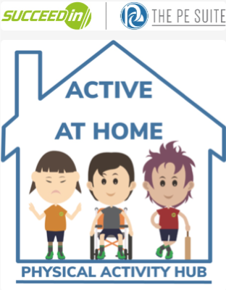
- Suceedin
Send this link home to parents so that they can access the resources- https://online.succeedin.co.uk/public/index/638
The URL will be updated daily as we see the need and demand grow especially if schools close.
Parents will also be able to access our home version on the platform where they will have access to the following:
- Games and Ideas to Play at Home
- Change for Life links to think about food and hygiene
- Active SATS papers provided by Link Up Play
- imoves
From this week, the imovement platform will contain additional resources that will support your teachers both in school and at home. Teachers, Parents and Children can access these resources for FREE
- New resources will be added on a daily basis, and will include Quick Blasts, Active Blasts and Additional Activities to support Maths and Literacy.
So remember, these FREE resources can be used in classrooms or in homes - they could be a great additional free resource for parents in home learning packs.
Accessing These Free Resources
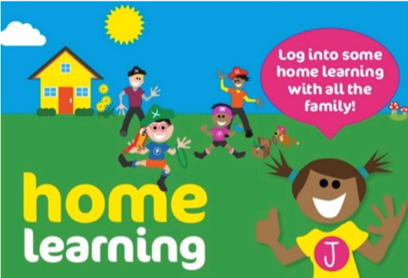
These resources are super easy to use - no login is required and no password. All moves ask is that teachers sign up using the link below - they will then receive an email with a link to all the resources which they can share with parents. Click Here to access the link.
- Create Development
Jasmin and Create Development would very much like to help as much as we can to alleviate the difficulties many families will face and we hope this offer will be of assistance.
real play at home supports families to play and learn together and includes 12 themes, 6 areas, over 250 activities and challenges, and 1000s of hours of fun and activity for every family! Existing real PE member schools will receive automatic FREE access whilst the schools remain closed to ensure all their families are given access to home learning online resources. Click Here to view the email that has been sent to real PE member schools
Open access to ANY school to real play at home. Create Development are really confident that we can support all families and are currently setting up over 6,700 of our member schools with access to the programme and are building capacity to extend this offer to all other primary, infant and junior schools. An expression of interest should be sent to jasmine@createdevelopment.co.uk
Access to other Key Stage 2 activities will also be available on the platform.

Why not learn (or improve) a skill; ‘My Personal Best’
There are lots of online video tutorials; why not learn to Hula-hoop, Juggle (2, 3 or more balls/objects), do Keepy-uppys (football or other ball/object), Skipping challenges

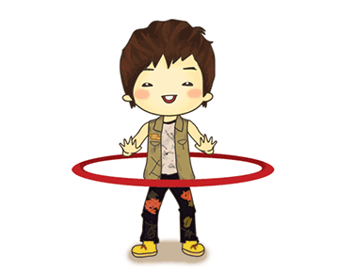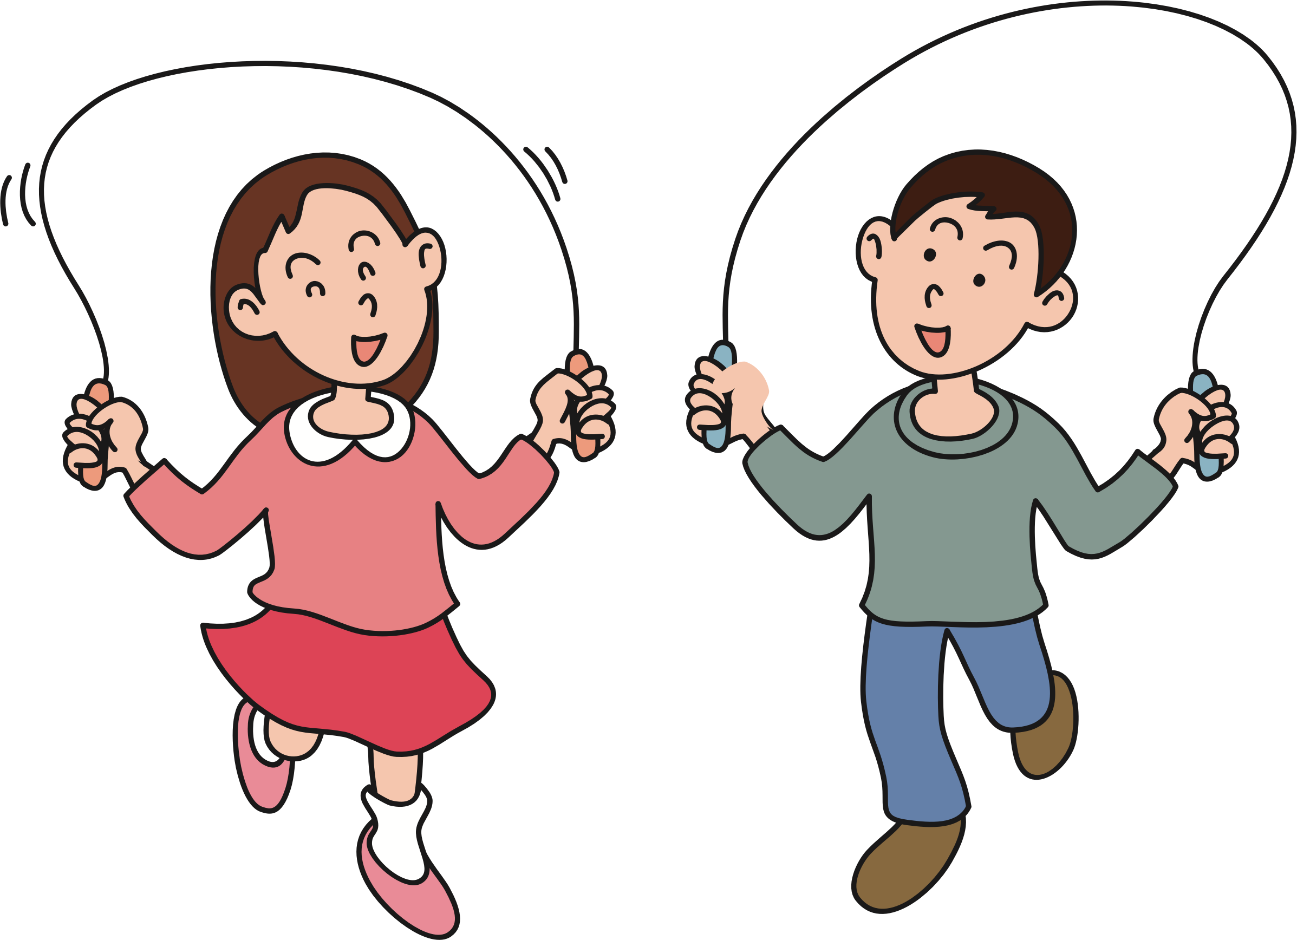
Try and improve your personal best. Practice a little every day.
Can you keep going for 1, 20, 30 seconds? How many can you do in 10, 30, 60 seconds?

School Games Challenges: these games/challenges could be adapted for all the family to play and with the equipment you have available
https://www.yourschoolgames.com/app/play-formats/11/ Spot Bucket Hoop
https://www.yourschoolgames.com/app/play-formats/4/ Keepy uppy
https://www.yourschoolgames.com/app/play-formats/50/ Reaction Challenge
https://www.yourschoolgames.com/app/play-formats/51/ Rebound
https://www.yourschoolgames.com/app/play-formats/8/ Scavenger Hunt

Garden Games
These are just a few suggestions of games that could be played in the garden. You can find lots of catching games and challenges online.
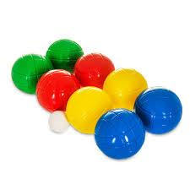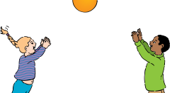

Garden Boule Catching games Frisbee catch

- Set some Personal challenges!
1.Stork balance
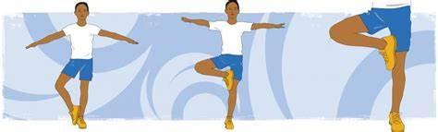
How long can you balance on one leg.
Now do the do the same balance but close your eyes.
Can you beat your score? Who in the family can hold this balance the longest?
2. Plank challenge
Who can hold the following plank poses for the longest?
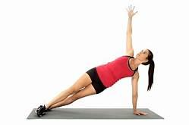

3. Football Keep ups & Freestyle challenges
https://www.youtube.com/watch?v=vnfg1u7tX5o
https://www.youtube.com/watch?v=J3-h3MV0yNw

4. Yoga exercises
Try holding these yoga poses.
If you like these poses below, try finding more on line. 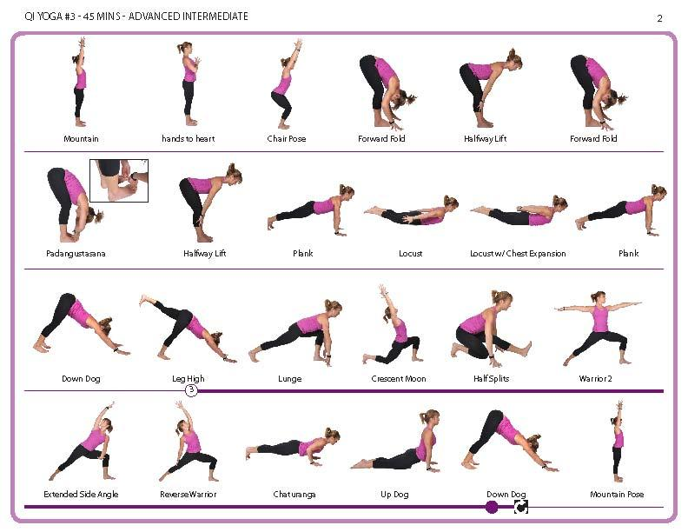

- Creative Minds: challenge yourself
Illustration tutorial: Rob Biddulph
Rob Biddulph is a children’s author and illustrator. Rob is posting daily online tutorials for children (and adults) to learn how to draw some of his favourite characters, including Gregasuras and Sausage Dog.
http://www.robbiddulph.com/draw-with-rob
Junior Bake Off
Fun recipes and challenges
https://www.bbc.co.uk/cbbc/shows/junior-bake-off
Horrible Histories
Do you know The Monarchs' Song from start to finish?
Horrible Histories superfans often brag about knowing 'The Monarchs' Song' off by heart... well, now is your time to prove it! How many tries will it take you to get all the way to Queen Elizabeth II?
https://www.bbc.co.uk/cbbc/quizzes/the-monarchs-song-kings-and-queens-quiz
Wildlife Challenge: How many different birds can you spot and identify in the garden?
Can you spot any birds (or wildlife) that you have never seen before?
https://www.rspb.org.uk/birds-and-wildlife/wildlife-guides/identify-a-bird/
Garden Minibeast Hunt: How many can you find and identify?
https://www.woodlandtrust.org.uk/blog/2019/04/minibeast-hunt/
100 Best Books to read before you’re 14: books for all ages
https://www.booktrust.org.uk/books-and-reading/our-recommendations/100-best-books/

There are some brilliant resources online too that would be good to include:
https://www.unicefkidpower.org/fun-sports-activities-games-resources-kids/
https://www.sportsrec.com/5185418/indoor-sports-activities-for-kids
https://kids.guinnessworldrecords.com/activities/try-this-at-home-backyard
https://www.verywellfamily.com/active-play-4157315
https://www.homeschooling-ideas.com/kids-sports-activities.html
https://www.homeschooling-ideas.com/homeschool-pe.html
https://familyeguide.com/boredom-busters-110-fun-at-home-activities-for-families-kids-2/

plus loads of stuff on youtube eg:
https://www.youtube.com/watch?v=WmGjxU3Ggko
https://www.youtube.com/watch?v=o8uTdn_zkok
https://www.youtube.com/watch?v=dhCM0C6GnrY
https://www.youtube.com/watch?v=8y6bIbr-Hn0

Plus…….we are sure you have tons of ideas yourselves!

Stay Healthy, Keep Active and we look forward to seeing you all very soon and hearing all about the fun you have had at home staying active!

