EYFS  ES | End of year expectations for mental calculations | End of year expectations for written methods and problem solving | Written strategies/ recordings/methods/images | Vocabulary  &  Links
 | - Count reliably up to 20  - Begin to relate addition to combining two groups of objects  - Add two 1-digit numbers  - Use more/less than to compare 2 numbers and quantities  - Find 1 more/less than any number to 10  - Partition numbers to 5 into 2 groups  - Know all number bonds to 10  - Use of games, songs and practical activities to count in 2s, 5s and 10s  - Begin using vocabulary of addition: double/half etc  - Solve simple word problems using their fingers and objects | - Make a record in pictures, words or symbols of addition activities already carried out.  - Construct number sentences to go with practical activities | Mostly pictorial representations:  X X X X X X X  X X X  Concrete apparatus models the addition of 3 objects and 2 objects by combining set  Simple number tracks to count up on:  6  5  4  1  2  3  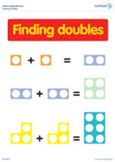  What is 1 more than 4?  1 + 1 = 2  +  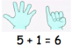  Can find one more to ten.  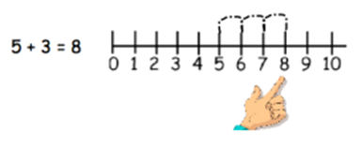  = | groups, sets, how many, how much, double, altogether, how many more than, how many more to make, hold the number

